1. **CONSTRUCTOR PROGRAM:**

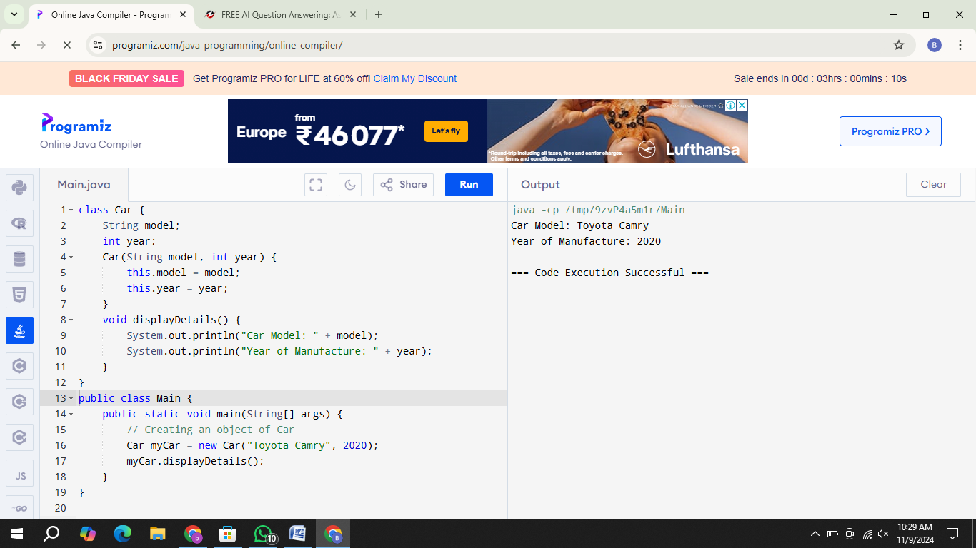

1. **COPY CONSTRUCTOR PROGRAM:**

